**Crypto Compliance 101: Transaction Monitoring in Web3**

[[CertiK](https://certik.medium.com/?source=post_page-----4bf3e03bb97e--------------------------------)](https://certik.medium.com/?source=post_page-----4bf3e03bb97e--------------------------------)

[CertiK](https://certik.medium.com/?source=post_page-----4bf3e03bb97e--------------------------------)

·

[Follow](https://medium.com/m/signin?actionUrl=https%3A%2F%2Fmedium.com%2F_%2Fsubscribe%2Fuser%2F48cc71597f8a&operation=register&redirect=https%3A%2F%2Fcertik.medium.com%2Fcrypto-compliance-101-transaction-monitoring-in-web3-4bf3e03bb97e&user=CertiK&userId=48cc71597f8a&source=post_page-48cc71597f8a----4bf3e03bb97e---------------------post_header-----------)

6 min read

·

Sep 7

2



Regulatory bodies around the world have laid down stringent laws and guidelines to govern the flow of money. These regulations aim to curb illicit activities like money laundering, fraud, and the financing of terrorism.

Yet the increasing number of high-profile scandals, like the [FinCEN Files](https://www.buzzfeednews.com/article/jasonleopold/fincen-files-financial-scandal-criminal-networks), reveals major failures in compliance by top financial institutions. And [the United Nations estimates](https://www.unodc.org/unodc/en/money-laundering/overview.html) the amount of money laundered every year at approximately 2–5% of global GDP. This represents anywhere from $800 billion to $2 trillion dollars, a sum up to double the total market capitalization of the cryptocurrency sector.

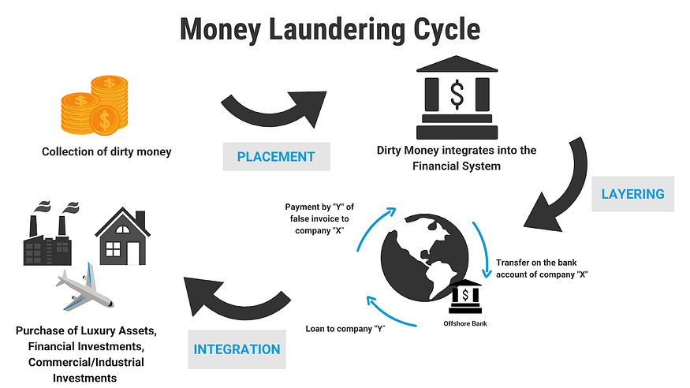

Source: [United Nations Office on Drugs and Crime](https://www.unodc.org/unodc/en/money-laundering/overview.html)

The need for effective compliance systems has never been more apparent.

The traditional finance sector (TradFi) relies heavily on centralized systems to monitor transactions and ensure compliance. But Know Your Customer (KYC) and Anti-Money Laundering (AML) regulations absorb a considerable amount of resources in the form of compliance specialists’ salaries and operational costs.

The total cost of financial crime compliance measures is more than a quarter of a *trillion* dollars a year, and it’s rising.

The average annual cost of financial crime compliance per organization has risen by double-digits since the pandemic began in 2020, with U.S. financial institutions reporting the highest YoY dollar changes.

[*– LexisNexis*](https://risk.lexisnexis.com/global/en/insights-resources/research/true-cost-of-financial-crime-compliance-study-global-report)

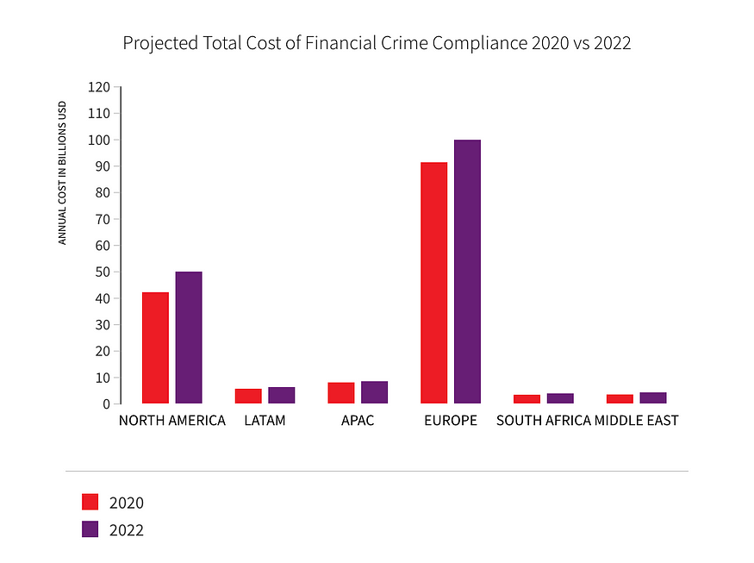

Source: [LexisNexis Risk Solutions 2022 True Cost of Financial Crime Compliance Study](https://risk.lexisnexis.com/global/en/insights-resources/research/true-cost-of-financial-crime-compliance-study-global-report)

Web3, the decentralized internet powered by blockchain technology, offers an alternative to these expensive, inefficient, centralized systems. Web3 technology provides a transparent, immutable ledger that can automate many compliance processes and drastically reduce the risk of fraud.

By harnessing the capabilities of Web3 technologies, financial institutions can revolutionize the compliance landscape. Smart contracts can automate KYC and AML procedures, while decentralized networks can offer real-time, tamper-proof transaction monitoring. This new era promises not just efficiency but also a far more secure and transparent system, capable of effectively scaling to meet the compliance demands of tomorrow.

**Blockchain’s Winning Combination for Crypto Compliance**

Blockchain technology brings to the table two crucial elements that can dramatically improve [crypto compliance](https://www.certik.com/products/skyinsights): transparency and auditability. Unlike traditional financial systems where records may be susceptible to alterations or unauthorized access, blockchain records are immutable. Once a transaction is validated and added to the blockchain, it cannot be changed or deleted. This provides a high level of protection against undetected financial crimes and money laundering.

The transparency of a blockchain is not just a design feature; it’s a strategic advantage for risk management. Every transaction is publicly recorded, and the entire transaction history of a particular crypto address is accessible to anyone who wants to see it. This public scrutiny adds an extra layer of due diligence, making it easier to spot suspicious activities. Financial institutions can leverage this transparent nature to improve their wallet screening processes and enhance their [know your transaction](https://www.certik.com/products/skyinsights) (KYT) systems.

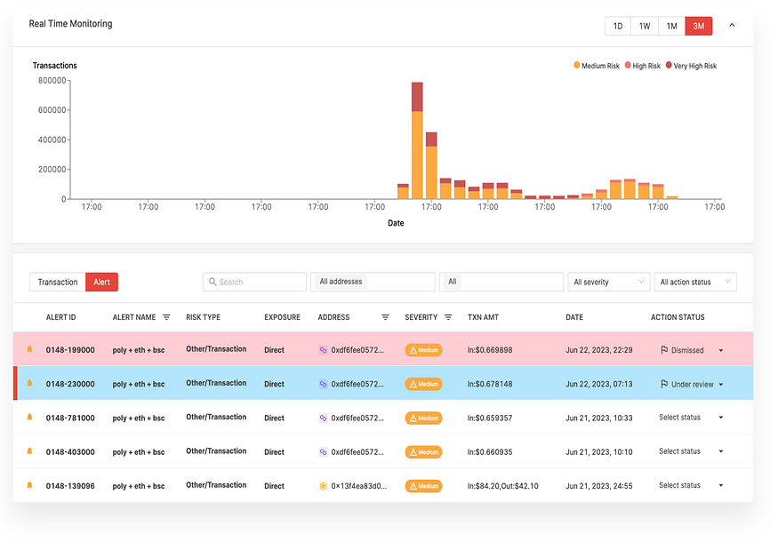

Source: [SkyInsights’](https://www.certik.com/products/skyinsights) Know Your Transaction Dashboard

Traditional financial systems have been beset with scalability issues, especially when it comes to real-time transaction monitoring. Blockchain technology — which underpins Web3 — offers a solution to this bottleneck. With the power of decentralized networks, transaction monitoring software can now handle a much larger volume of customer transactions more efficiently. Blockchain transactions are public by default, making a Big Data approach much more feasible.

Smart contracts play a pivotal role in this context. These are self-executing contracts with coded rules that automatically trigger when conditions are met. When it comes to [crypto compliance](https://www.certik.com/products/skyinsights), smart contracts can be programmed to automate a multitude of tasks, saving money and saving time.

The use of machine learning can further hone the accuracy of monitoring transactions. Algorithms can be trained to differentiate between normal and anomalous transaction data. This helps to reduce the number of false positives that often plague AML software.

This combination of smart contracts and machine learning doesn’t just lead to a more efficient case management system; it also paves the way for a new paradigm in AML and [crypto compliance](https://www.certik.com/products/skyinsights).

**How Crypto Compliance and Risk Management can Elevate the Web3 Industry**

**Meeting Regulatory Requirements**

Transparency is not just a buzzword; it’s an essential component of regulatory compliance. In the crypto industry, Web3’s inherent transparency comes from its public and immutable blockchain records. This feature greatly aids in risk management, as it helps to facilitate the thorough due diligence required for monitoring cryptocurrency transactions. By utilizing machine learning, Web3 businesses can sift through transaction data more efficiently, identifying suspicious activities that could be indicative of money laundering or dealings with sanctioned entities.

In the quest for [crypto compliance](https://www.certik.com/products/skyinsights), it’s incumbent upon forward-thinking Web3 firms to take proactive steps to align with regulations. These steps include adopting sophisticated transaction monitoring software, implementing [know your transaction](https://www.certik.com/products/skyinsights) (KYT) protocols, and continuously updating their anti-money laundering (AML) solutions.

**Attracting Institutional Participation**

The financial industry has long grappled with the need for stringent compliance, especially to attract institutional investors. For Web3 and the broader crypto industry, compliance isn’t just a regulatory necessity but also a competitive advantage. Institutional investors seek reliability, and[crypto compliance](https://www.certik.com/products/skyinsights) can offer just that by using advanced AML solutions and[transaction monitoring software](https://www.certik.com/products/skyinsights).

Transparency plays a vital role in winning over these institutional players. The openness of blockchain data builds a level of trust that is often lacking in traditional financial systems. By having a transparent ledger of cryptocurrency transactions, institutions can perform their own due diligence with unparalleled depth. It allows them to verify the effectiveness of a Web3 business’s risk management strategies and ensures they are not associating with financial crimes or money laundering activities.

**What Effective Transaction Monitoring Tools Can Do**

**Real-Time Analysis and Case Management**

A cutting-edge [crypto compliance](https://www.certik.com/products/skyinsights) solution goes beyond merely flagging suspicious activities. It employs real-time analysis, allowing financial institutions to instantly identify irregular patterns in customer transactions.

This enables rapid detection of unusual activities and assists in reducing false positives. Meanwhile, effective case management features allow compliance teams to keep track of ongoing investigations and coordinate actions seamlessly.

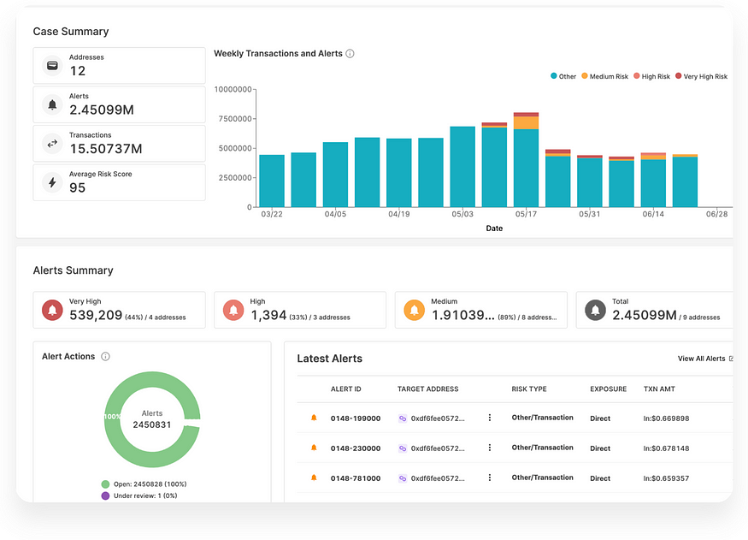

Source: [SkyInsights’](https://www.certik.com/products/skyinsights) Case Management Dashboard

**Comprehensive Wallet Screening and Know Your Transaction (KYT) Protocols**

To meet stringent anti-money laundering (AML) and risk management requirements, an advanced platform includes robust wallet screening functionalities. It can automatically cross-reference crypto addresses against a database of sanctioned entities, high-risk jurisdictions, and other flagged accounts. Know Your Transaction protocols further enhance this by providing in-depth contextual information surrounding each transaction.

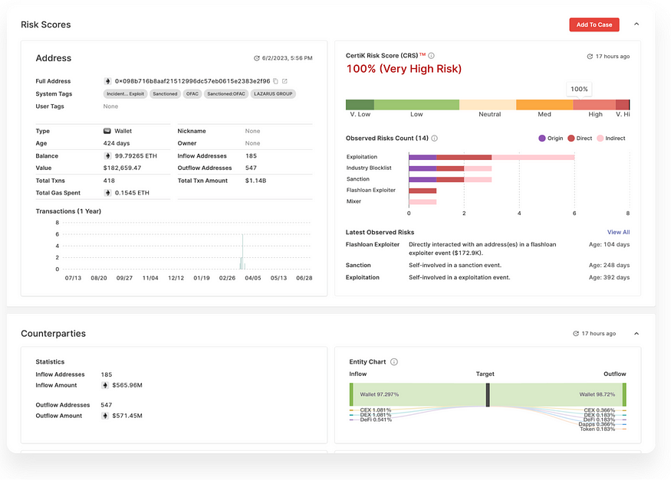

Source: [SkyInsights’](https://www.certik.com/products/skyinsights) Wallet Screening Tool

**Scalable Solutions**

The most effective transaction monitoring solutions are designed to scale. They can handle a vast volume of transactions without compromising speed or efficiency. Additionally, they offer customizable settings to better align with an institution’s specific compliance policies and procedures.

**Integrated Machine Learning for Optimized Monitoring**

Machine learning capabilities are integrated into the monitoring framework to analyze and predict emerging threats. This proactive approach allows the system to adapt to new forms of financial crimes.[Transaction monitoring tools](https://www.certik.com/products/skyinsights) should be ever-evolving to stay at the forefront of the fight against money laundering.

**Automated Compliance through Smart Contracts**

In a transparent Web3 environment, smart contracts can be utilized to automate various compliance tasks. These self-executing contracts, working off predefined rules, can automatically report a suspicious transaction to authorities or freeze assets pending investigation.

**Blockchain and Beyond: Transforming Crypto Compliance**

The crypto industry stands at a momentous juncture. Web3 technology offers the tools to drastically enhance compliance and risk management. Blockchain’s transparency, real-time transaction monitoring capabilities, and smart contracts can lead to a future where compliance is not a burden but a strategic advantage.

As traditional financial institutions struggle with scalability and efficiency, Web3 is setting new benchmarks. The future of [crypto compliance](https://www.certik.com/products/skyinsights) is not just about meeting regulations but exceeding them. This will pave the way for broader institutional participation and a more secure, transparent financial landscape.

<https://certik.medium.com/crypto-compliance-101-transaction-monitoring-in-web3-4bf3e03bb97e>